1) List the employee’s name, job, salary, and department number for those employee working in Smith’s department

select ename,job,sal,deptno from emp where deptno=(select deptno from emp where ename='SMITH')

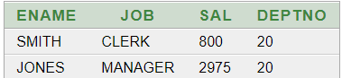

2) . Display salary of employees according to department and job those are getting salary more than average salary.

select deptno,ename from emp where sal>(select avg(sal) from emp)

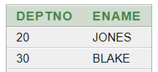

3) . Display Deptno, Empno and name, those have department name “Operations”.

select deptno,ename,empno from emp where deptno=(select deptno from dept where dname='OPERATIONS');

no data found

4) List Ename, job, annual Sal, and Deptno for employees, who earns more than Jones salary

select ename,job,sal,deptno from emp where sal>(select sal from emp where ename='JONES')

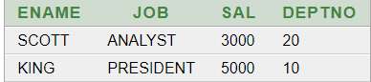

5) . Display the employees those have joined after miller .

select ename, hiredate from emp where hiredate>(select hiredate from emp where ename='MILLER')

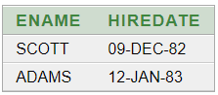

6) Find the employees who earn salary equal to the minimum salary in the company.

select ename,sal from emp where sal=(select min(sal) from emp)

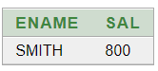

7) . Find all employees who have the same job as BLAKE.

select ename,job from emp where job=(select job from emp where ename='BLAKE')

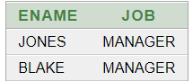

8) . Find all the employees who earn more than every employee in department 30.

select ename,sal from emp where sal>ALL(select sal from emp where deptno=30)

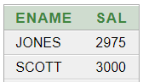

9) . Display employees who earn more than the lowest salary in department 30.

select ename,sal from emp where sal>(select min(sal) from emp where deptno=30)

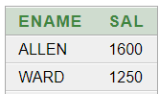

10) Display the departments, which have an average salary more than that of department 30.

select deptno,avg(sal) from emp group by deptno having avg(sal)>(select avg(sal) from emp where deptno=30) ;

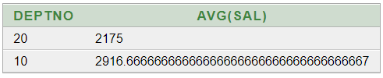

11) Display the job with the highest average salary.

select job,avg(sal) from emp group by job having avg(sal)>=ALL(select avg(sal) from emp group by job)

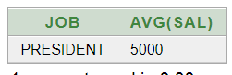

12) . For each employee display the number of days passed since the employee joined in the company

select ename, round(months_between((select sysdate from dual),hiredate)*365/12,0) as "DAYS SINCE JOIN" from emp

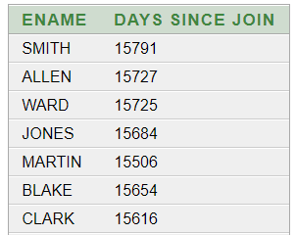

13) Display the employee those are working department of location Chicago in the company.

select ename from emp where deptno=(select deptno from dept where loc='CHICAGO');

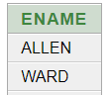

14) . Display the name, job and hire date of employees whose salary is greater than the highest salary of sales department.

select ename,job,hiredate from emp where sal>(select max(sal) from emp where job='SALESMAN')

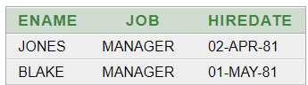

15) . Find the 2nd maximum salary of employees.

select max(sal) from emp where sal<(select max(sal) from emp)

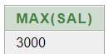

16) . Count the department where no of employees are more than 5.

select count(*) from (select deptno,count(*) from emp e group by deptno having count(*)>5)

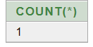

17) Count the no of employees those are not getting any commission.

select count(*) from emp where comm is null;

